Installing an Ubuntu Virtual-Box on Windows!

# Introduction:

Virtual-Box is free software to set up a virtual computer to run in the environment of your current computer. This environment is ideal for code testing and safe software development. We will demo a basic Ubuntu Virtual-Box installation here as a guide for first-time users.

# Overview:

These instructions cover a minimal default installation of an Ubuntu Virtual box onto a Windows home PC. For our purposes, the default setting will be ideal and an LTE Ubuntu image will be the best choice for an Ubuntu image!

# Requirements:

* Reliable internet connection.
* A Windows machine running Windows 10 or later.
* Administrator privileges.
* 1028 GB spare memory
* A multi-core pc running 4 or more cores.

# Instructions:

## **Download the Windows version of Virtual Box. S**tart by navigating, in your internet browser, to the page <https://www.virtualbox.org/wiki/Downloads>. From here we will click the Windows Host hyperlink. This will prompt the download to star

## **Install the virtual box hosting tool.** Once the VirtualBox download finishes double-click the file to initiate the installer tool. **If the Windows firewall blocks the tool, allow it to make the changes it needs**!

Cycle through the download tool keeping the default setup(meaning we need not make changes on any of the tiles we cycle through). Until finally we get to the final prompt to install.

1. Graphical user interface, text, application, timeline, Teams

   Description automatically generated**Download the desired Ubuntu desktop image.** To retrieve this image we will navigate, in our web browser, to <https://ubuntu.com/download/desktop>. From here we will single-click the large green Download button to start the download.  **Be aware this download make take a few minutes**

## **Create our virtual box.** Now that we have all our downloads and have installed the virtualbox tool, we will create the box. In VirtualBox manager window select the “New” button. This prompts a new window. We can name this Virtual Box whatever we want. **Importantly we need to make sure we select a Linux Type and Ubuntu(64-bit) Version.**

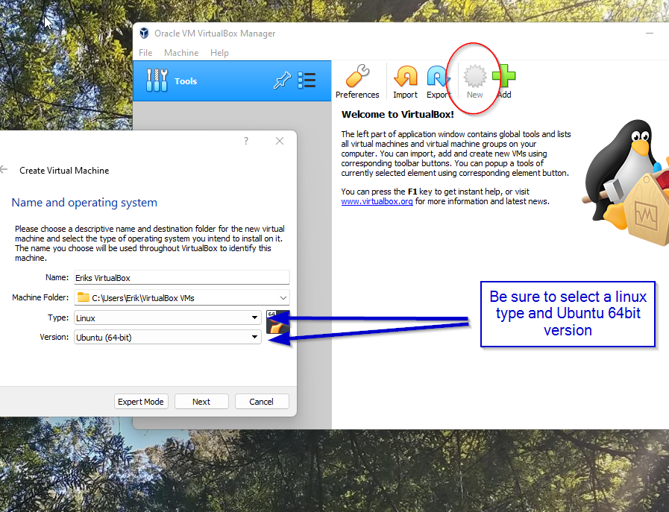 After selecting the type and version, we cycle through the rest of the creation tool, again selecting the default options. (Not changing the settings pre-loaded in each window).

1. **Allocate more cores to your VirtualBox.** Before starting our virtual box we need to allocate more processing power. In the manager, the window selects the settings button of our new VirtualBox. From here we select the System tab from the right-side tab menu. We then will select the processor tab and slide the scroller to 3 processors and click the “OK” button.

1. Graphical user interface, application, Word

   Description automatically generated**We can now start our VirtualBox.** While in the same selection in our manager we can now hit the green Start arrow to open the initial setup prompt. From this menu click the little yellow folder and select add new disk image. From the pop-up window, navigate to where your downloaded Ubuntu file was saved. Select this image and select OK. Then select Start from the original window.
2. Graphical user interface, application

   Description automatically generated**Initialize your Ubuntu installation.**  Your virtual box should now start in a New Window. There will be a notification for Autodetecting the keyboard and mouse this is ideal. The machine will come to the Ubuntu startup menu, from here select, using the arrow keys “Try or Install Ubuntu”, and hit return. The next screen you see should be this

# Congratulations:

You have now set up your own Ubuntu VirtualBox. The rest of the Ubuntu setup will take care of itself and then you will have access to your Virtual Machine. In the manager, this environment can be changed edited, or deleted at any point. You can always force an exit from a machine by clicking the X button in the top right. Enjoy your new synthetic computer!

# Works-Cited:

All images:

**Erik Sundblad.  Screenshots of setup. 16 Sept. 2021. Author's personal collection.**